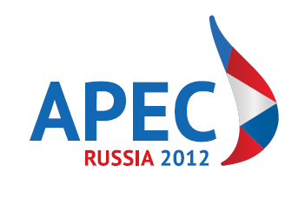
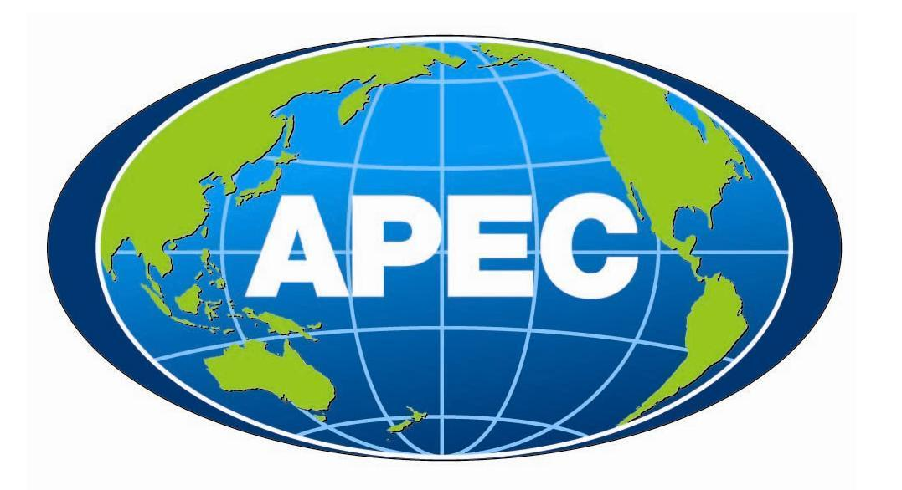

19th APEC FINANCE MINISTERS’ MEETING

JOINT MINISTERIAL STATEMENT

1. We, the finance ministers of the APEC economies, convened our 19th annual meeting in Moscow, Russian Federation, on August 30, 2012 under the Chairmanship of Mr. Anton Siluanov, Minister of Finance of the Russian Federation. The meeting was also attended by the President of the Asian Development Bank (ADB), the Managing Director of the World Bank Group, the Deputy Managing Director of the International Monetary Fund, the Deputy Secretary General of the Organization of Economic Cooperation and Development (OECD), Pacific Economic Cooperation Council (PECC) and the APEC Business Advisory Council (ABAC).

2. We gathered at a time of high uncertainty and significant downside risks for the global economy. Financial markets continue to be fragile, while some advanced economies globally face challenges associated with high public deficits and debts. The events in Europe are adversely affecting growth in the region. Economic activity in a number of advanced economies has weakened and there are clear signs of slowing growth in the emerging economies that remain heavily dependent on external demand. In such circumstances, we reaffirm our strong commitment to support growth and foster financial stability. Specifically, we are committed to strengthening domestic demand where appropriate and restoring confidence, facilitating job creation, reducing high public deficits and debts, and implementing structural reforms to boost growth and reduce external imbalances. We welcome recent policy measures that support demand and are generating some positive outcome.

3. APEC members remain vigilant of the substantial risks posed by elevated oil prices and welcome appropriate action by the International Energy Agency to ensure that the market is fully and timely supplied. We will also remain vigilant of other commodity prices, highlighting the need to avoid export bans, and other restrictions that are inconsistent with WTO rules in response to rapid increases in agricultural commodity prices.

4. We support the conclusions of the recent G-20 Leaders Summit in Los Cabos on 18-19 June 2012 and will act together to strengthen the global recovery and ensure strong, sustainable and balanced growth. We welcome European Leaders’ commitment to take all necessary measures to safeguard the integrity and stability of the Euro area. We agree to intensify our efforts to implement reforms to bolster financial sector stability. We remain committed to reducing imbalances by strengthening deficit economies’ public finances with sound and sustainable policies that take into account evolving economic conditions and, in economies with large current account surpluses, by strengthening domestic demand and moving toward greater exchange rate flexibility. We reaffirm our commitment to move more rapidly toward market-determined exchange rate systems and enhance exchange rate flexibility to reflect underlying fundamentals, avoid persistent exchange rate misalignments, and refrain from competitive devaluation of currencies. While capital flows can be beneficial to recipient economies, we reiterate that excess volatility of financial flows and disorderly movements in exchange rates have adverse implications for economic and financial stability. We are firmly adhered to open trade and investment, expanding markets and resisting protectionism in all its forms.

5. Fiscal sustainability remains an important element of sustained economic growth. Good governance in public finance enhances the credibility of budgetary policy and promotes economic recovery. Recent financial crises resulted in a substantial deterioration of fiscal accounts in many of the world’s economies. Under these difficult circumstances, we remain committed to ensuring the long-term fiscal sustainability of our economies while recognizing that short-term fiscal stimuli may be warranted to support growth and job creation in economies with available fiscal space. Advanced APEC economies will ensure that the pace of fiscal consolidation is appropriate to support the recovery in their economies while also addressing concerns about medium term fiscal sustainability. APEC emerging market economies with sufficient fiscal space stand ready to implement discretionary fiscal actions to support domestic demand, as appropriate.

6. We recognize the importance of closely monitoring vulnerabilities stemming from the build-up of excessive private debt. During crises, the liabilities of the private sector, including distressed financial institutions, may turn into increased liabilities of the public sector, increasing risks to fiscal sustainability. Expenditures related to population aging should also be taken into account in fiscal projections.

7. APEC remains a valuable forum for discussion of practical measures to advance issues of mutual concern to member economies. Our discussions this year have increased our understanding of three important topics: financial inclusion, in particular financial literacy, financial policy measures to address the impact of natural disasters, and treasury systems.

8. We recognize the importance of financial literacy as a critical life skill in the 21st century that can contribute to individual and families’ wellbeing as well as to financial stability in our economies. Financial education is also an essential complement to consumer protection and financial inclusion in any economies’ efforts to support economic growth. Taking these factors into account we adopt today the Policy Statement on Financial Literacy and Education (Annex). We welcome the endorsement of the OECD/INFE High-level Principles on National Strategies for Financial Education by G20 Leaders at their Summit in Los Cabos and welcome the OECD|INFE, the World Bank and ADB’s cooperation with the Global Partnership for Financial Inclusion (GPFI). We also welcome the development of members’ policies that integrate financial literacy, consumer protection and financial inclusion objectives. We support the development and implementation of member economies strategies for financial education and encourage them to take into consideration the methodologies and tools developed by the World Bank and the OECD/INFE.

9. We especially recognize the importance of financial education for the young and welcome the OECD/INFE Guidelines for Financial Education in Schools. We encourage their implementation in APEC economies, taking into account economy-wide, regional and local circumstances. We also encourage the APEC economies to consider the participation in the Financial literacy measurement in the Programme for International Student Assessment (PISA).

10. We note the APEC-sponsored workshop organized in May by the Philippines and the United-States in Manila on incorporating financial inclusion objectives in electronic government-to-persons payments.

11. In view of high economic costs incurred by many APEC economies due to natural catastrophes in recent years, we reiterate the importance of strengthening our resilience against disasters. The development and adoption of coordinated disaster risk management (DRM) strategies are important in this regard. We look forward to the “Sendai Dialogue”, a special event on mainstreaming DRM for sustainable growth, to be co-hosted by Japan and the World Bank in October. We recognize that integrated disaster risk financing policies are part of overall disaster response preparedness. In developing these policies, attention should be given to advance planning and preparation by financial authorities, including the maintenance of effective and resilient payment systems and, where appropriate, the introduction or expansion of risk sharing and risk transfer market products.

12. We note innovations introduced in disaster response policies and practices over the last years. In this regard we support the exchange of knowledge and best practices about such practices within the international financial institutions (IFIs) and look forward to the presentation next year of guidelines for financial authorities’ responses to natural disasters developed in collaboration with the World Bank, the OECD, the ADB and other bodies, which will complement the work undertaken by the G20. We consider that such syntheses of best practices will assist our economies in designing and implementing both comprehensive DRM strategies and specific policy measures tailored to specific country circumstances.

13. Treasury systems are an indispensable element of public financial management and we welcome the exchange of experience on this topic by our finance and treasury officials. Treasury systems’ broad modernization is of high practical importance, and collaboration on this issue necessitates new levels of cooperation. We welcome voluntary bilateral and multilateral exchanges or co-operation on technical issues between finance and treasury authorities of APEC economies. These exchanges engender a constructive dialogue to identify common principles and effective mechanisms for treasury systems development and modernization.

14. We welcome intensive public-private collaboration in developing our region’s financial systems. We support ABAC’s proposal to explore the creation of an Asia-Pacific Financial Forum through a symposium in early 2013 and welcome the Australian Government’s commitment to hold the event.

15. We encourage the public and private sectors to work closely together to further expand the Asia-Pacific Infrastructure Partnership Dialogues in 2013. We took note of the results of this year’s Asia-Pacific Financial Inclusion Forum and welcome ABAC’s continued work on APEC’s financial inclusion agenda.

16. We note the technical work that is underway to gradually progress the development of an Asia Region Funds Passport (ARFP). Taking into account this progress and the different regulatory, economic and market conditions of economies in the region, as well as efforts by ASEAN to better integrate capital markets, we look forward to further development of the proposed model, governing arrangements and policies for a pilot ARFP.

17. We thank the Russian Federation for its 2012 Presidency and for hosting the successful Moscow meeting. We will meet again for our 20th meeting in Nusa Dua Bali, Indonesia, on September 20, 2013.

